**Web Hosting**

Creating a custom Docker image

* Follow the set of commands shown below to build a custom Docker image:

**git clone** [**https://github.com/ SpringBootDocker.git**](https://github.com/Anuj1990/SpringBootDocker.git)

**ls -lart**

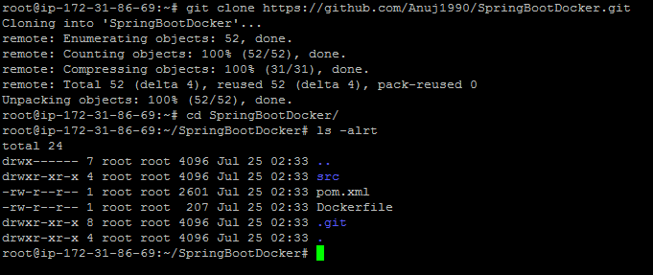

* Build source code to generate artifacts which can be deployed on Docker host.

**mvn clean install**

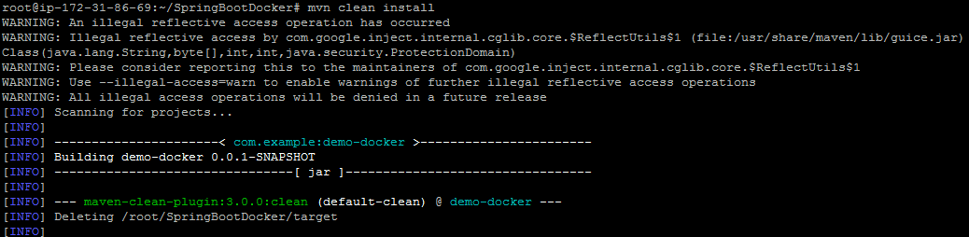

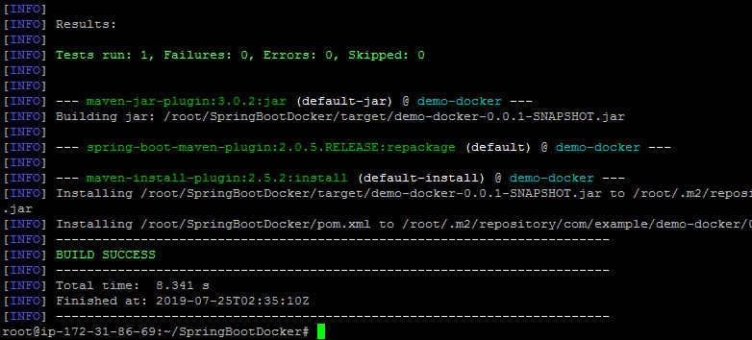

* Deploy this artifact inside the custom Docker image using **docker build** command line. Follow the steps shown below to create the custom Docker image:

**docker build -t springbootapp .**

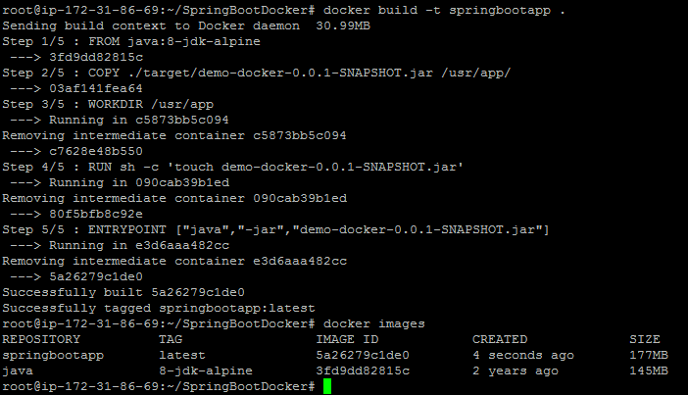

* Push this image to Docker Hub. Follow the command below to do so.

**docker images**

**docker tag springbootapp springboot**

**docker push springboot**

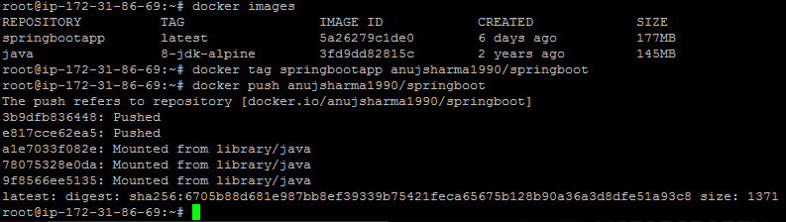

Deploying a Spring Boot application to AWS EKS

* Configure **kubectl command line** and deploy containers to AWS EKS.

**export PATH=$HOME/bin:$PATH**

**kubectl get node**

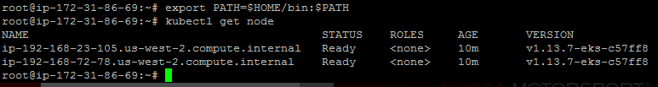

* Create Kubernetes deployment and service using the set of commands given below:

**kubectl run springbootapp--image=anujsharma1990/springboot --port=8080**

**kubectl expose deployment/springbootapp --port=8080 --target-port=8080 --type=LoadBalancer**

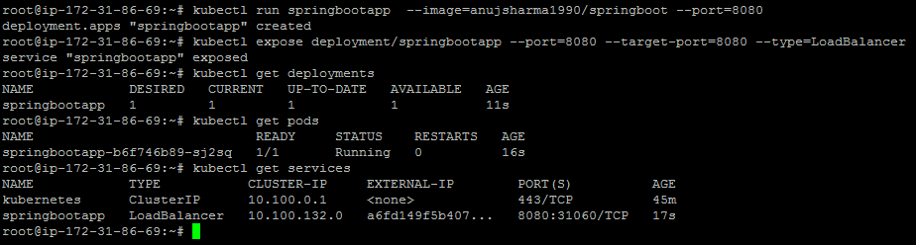

**Please Note:** Once the pod is deployed, we can get the Load Balancer URL from springbootapp EKS Service. EKS will automatically configure the Load Balancer in AWS.

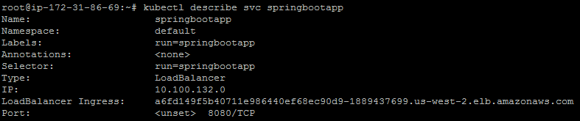

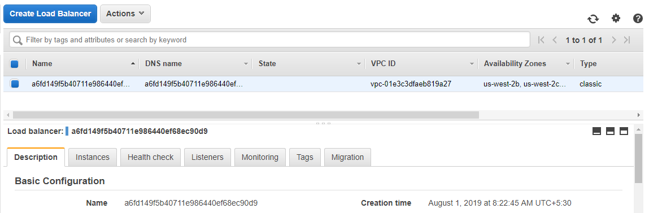

* To access the Spring Boot application, use the **Load Balancer URL** as shown below.

**curl -w "\n" a6fd149f5b40711e986440ef68ec90d9-1889437699.us-west-2.elb.amazonaws.com:8080/greet/EKSSpringboot**

